Implementation of Strategic Management Information System for Andhra Express

National College of Ireland

School of Computing

MSc Data Analytics

Team Details

|  |  |  |
| --- | --- | --- |
| Student Name | Student Number | Workload Distribution |
| Ranu Kishor Parate | x17161452 | 25% |
| Jahnavi Kacharakanahalli Shesha Reddy | x17170010 | 25% |
| Samir Salim Khan | x17161461 | 25% |
| Anurag Abhay Singh | x18104053 | 25% |

Organizational Background Information:

Andhra Express is startup company founded in year 2016 by T Avinash Reddy, a graduate engineer who worked as a manager in a restaurant, based in Bangalore. From work there he learnt about different aspects of food industry and thought there is the improvement need to be done in supply chain of food industry therefore he started his own venture, Andhra Express. He organized campaigns from where he developed contacts and his team started visiting corporate companies in Bangalore and provided them the samples of the food they prepared. Due to mouth marketing and service relationship they developed a brand in market which help them to have multinational corporate companies like Infosys, TCS in testimonial in one year. After success they adopted different strategy of going to ground scale by adopting B2C strategy and started selling food through there restaurant to single consumer by taking regular orders by just clicking on their registered website or manually calling them. The food service which started off with just a basic Andhra meal (Typical south Indian meal) but now has spread through different cuisines like North Indian, Tandoor and Chinese Meals. They have also included different food items like soups, veg starters and then they started serving drinks like mock-tails and juices. The successful growth of the restaurant in just one year proves the dedication and work involved in building this venture by understanding food consumer market requirement.

Market place and Scope:

The business line of Andhra express is serving regional foods to corporate companies and to basic consumer on their demands. At present corporate companies in range of 5kms are being targeted as customer by Andhra express. Centralized location to all corporate companies gives Andhra express competitive edge over other app base food delivery. Since foods match and follow all the health standard set by food industry, the company has create a good brand in market. The success in Bengaluru has open new market horizon for company which look to open new venture in different states.

The main reason for choosing Andhra express for our project is to learn their smart business strategy adopted to understand market. At present provided service to the corporate companies have been highly efficient because of transportation range of 5 kms. Since the venture is being limited to certain aspects like the range of delivery as well as the service is being limited just to corporate companies there is a great scope of improvement as well as the expansion of the business. The customer acquisition cost, customer retention are important factors which will decide longevity of venture because capital return will result into expansion of venture in different regions. Motto of company is quite clear to provide best service so keeping the customer satisfaction as priority business model has been developed by providing fast services to people at home by creating an online interactive website/portal with multiple food option where they can place an order from the wide range of regional foods available, whereas all the back-end work such (Customers’ orders, Initiating emails regarding offers and discounts, food tracking updates via mail/messages) will be managed using Salesforce. The customers will be benefited will have opportunities to avail discounts after multiple login. Diversified festival is add on advantage which results in special offer because demand might be high with respect to time so mass production of food is possible. Customize freedom is given to customer to select their meals as well as last second cancellation of order. From the business point of view, we can use local transportation service for the quick food delivery services they provide around the city of Bangalore. The tie-up with such transportation will resolve the issue of range and will enable our services to reach out all across Bangalore. A minimum commission of such transportation service companies will add up in the total billing amount of the customer which will tend to be around ₹ 3- ₹ 5 depending on the location of the customer.

Organizational Infrastructure:

For our project customer relationship management platform Salesforce is used for implementation. Since it has integrated with all features requires marketing and sales. SWOT analysis is used to define our project because it has certain critical factors which evaluates growth of company.

**Strengths:** 1. Centralized access connection to large consumer database to everyone in company due to which transparency is achieved. 2. Customer relationship is easily build because of interactive interface website. 3. Supply chain management is improved so which saves lot of time and money. 4. Role of middlemen is eliminated so product can be delivered at faster, cheaper rate. 5. Fully automated service helps in reducing workforce and using workforce in areas to be improve. 6. High data protection because whole data is stored in cloud.

**Weaknesses:** 1. Salesforce training required at initial phase and at every phase someone should be there to operate it because system can’t be left ideal if whole process is dependent on it. 2. Resistance to adoption of Salesforce system because initial cost to build new system and replacing existing system. 3. Data Privacy because of multiple user operating the system. 4. Easy to learn which can bring competitive advantage.

**Opportunities:** 1. Since real time data is obtained, relationship can be built which enables user to predict market requirement and change system according to nature of market. 2. Leads can be converted to sale easily because system has already prepared organization about customer requirement. 3. Big market can be created around this system because transportation, storage management can be done easily.

**Threat:** 1. Risk of losing data if system is not managed properly by end user.

Sales Process of Andhra Express:

At initial customer logged in to website portal created by Salesforce, automatically Customer_ID is generated attached to that customer, then he is shown the possible list of food items prepared by vendors of Andhra Express by drop down list. After easy search different quantity of food he select.

After choice of food Food_ID is generated for system use,person is shown the payment option, according to which he selects convenient mode of payment. After going into payment section, if payment procedure is followed properly, then its reflected in account section of Salesforce system the customer_id, food_id, payment_id, if the user of system approves it then order is processed and order_id is generated which is transferred to transportation.

Until order is processed delivery department works to get ready for delivery of order to avoid last minute chaos. If payment has to be done on delivery which customer selects as mode of payment ,delivery_id is taken in reference by Salesforce user, then delivery person is informed about it to receive payment and it’s updated in system. For such time delivery system status is pending and from time till it reaches customer delivery it reflects as in process in system. And when receiver confirms the delivery the delivery_id is matched with food_id of customer_id and the customer is asked about about confirmation of delivery, for which if it confirms then feedback is asked.

Sales force treats organization/owner/ manager as an Account. After implementation of sales we will be reporting and providing the dashboard outputs to the owner of the organization Mr. Avinash Reddy. The customers who surfaced the website but not done any buying of foods products or services are considered leads by Salesforce system.

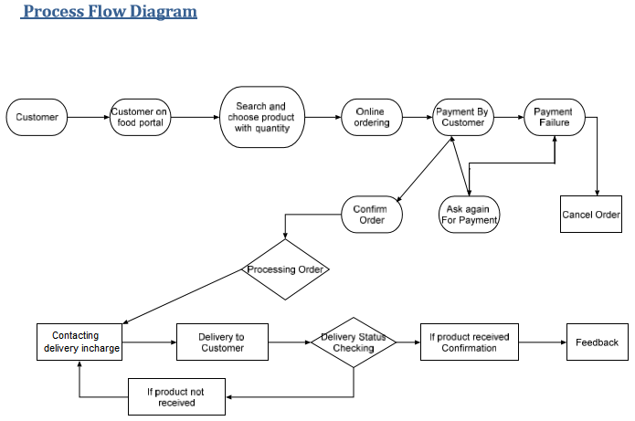

Dashboard and Reporting/Analytical Requirement:

The prime purpose of implementing this project on this platform is that it should provide a way for the higher authorities or the person on the managerial level so that it has all the summarized data in forms of reports so that crucial business related decisions can be made so as to increase the profitability or to analyze and improve the lacking sectors of the business. Even though various reporting and visualization tools are available, we will be doing it in Salesforce all the back-end working is being managed on it.

The reports that are going to be generated will be visualized using the dashboard.

Following 5 reports were created to answer the BI queries and all these created reports were into one single dashboard:

1. Preferred payment method.
2. Most Delivery by the person in a particular month.
3. Most number of orders in a certain month.
4. Most sold meal.
5. Most orders as per location.

Entity Relationship:

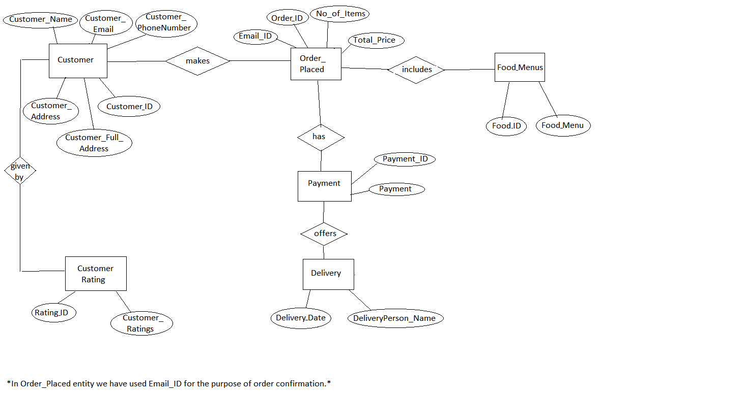

For this project the following entities are selected

* Customer
* Order_Placed
* Food_Menus
* Payment
* Delivery
* Customer_Rating

In customer entity all data is feeded related to customer like name, location, contact ,Orders entity consist of data about quantity of product, food menu consist of price, name, Payment entity simply consist of payment section, payment method, Feedback entity consist of reviews, rating, customer name, Delivery entity consist of order number, name of person to whom product is delivered.

The table below clears the attributes & data types assigned to different entities.

|  |  |  |
| --- | --- | --- |
| Entity | Attributes | Data Type |
| Customer | Customer_Name | Text |
| Customer_ID | Auto Number |
| Customer_Full_Address | Text |
| Customer_Address | Text |
| Customer_Email | Text |
| Customer_PhoneNumber | Number |
| Order_Placed | Order_ID | Auto Number |
| Email_ID | Text |
| No_Of_Items | Number |
| Total_Price | Currency |
| Food_Menus | Food_ID | Auto Number |
| Food_Menu | Text |
| Payment | Payment_ID | Auto Number |
| Payment | Picklist |
| Customer_Rating | Rating_ID | Auto Number |
| Customer_Ratings | Picklist |
| Delivery | DeliveryPerson_Name | Text |
| Delivery_Date | Date |

Implementation:

Objects: Various objects have been created to store multiple data forms to create a linear simplified database which can help end user to provide reliable service to clients. Then later all created objects are related to each other to build a proper structured database model.

**Customers:**

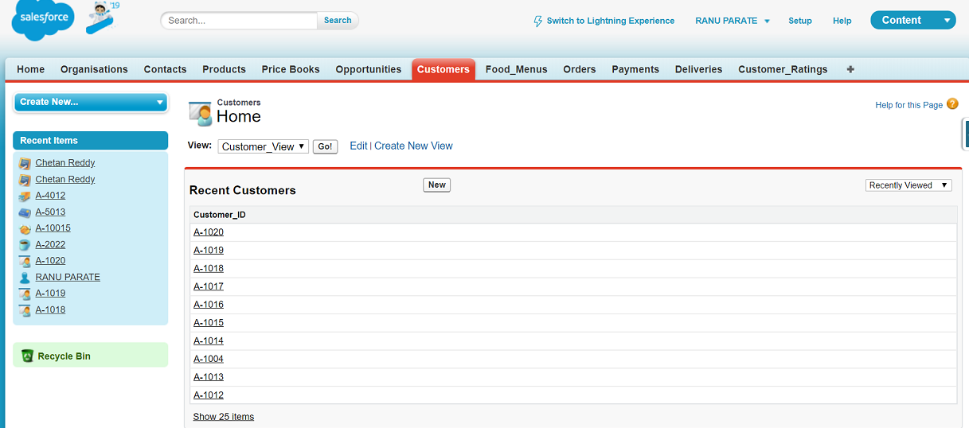

The displayed screenshot shows object customer. The object Customers stores information of different customer who have placed orders on the registered portal under attributes Customer_ID and data type assigned to them are auto number. The customer objects fields on portal required where customer enter his personal data which is shown below.

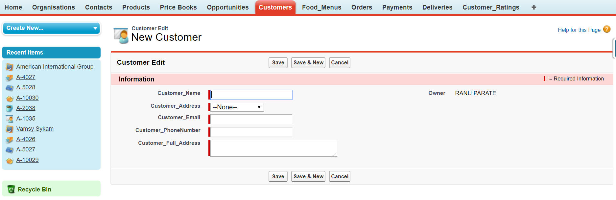Customer object is designed in such way that it has fields to stores all necessary information of customer, like name, address, contact no, email id, full address.

**Customer Fields:**

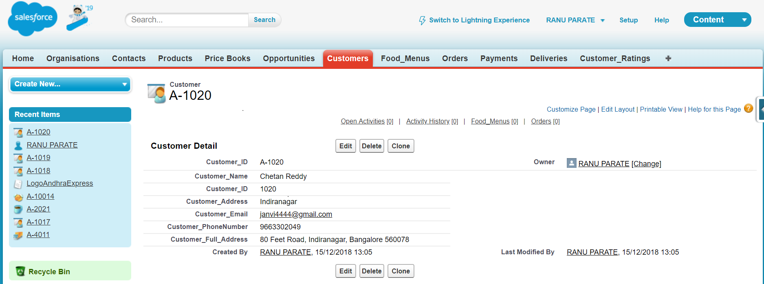

As soon as customer fills all his details Customer_ID is generated and attach to that filled data by customer which reflects in our system.

**Food_Menus:**

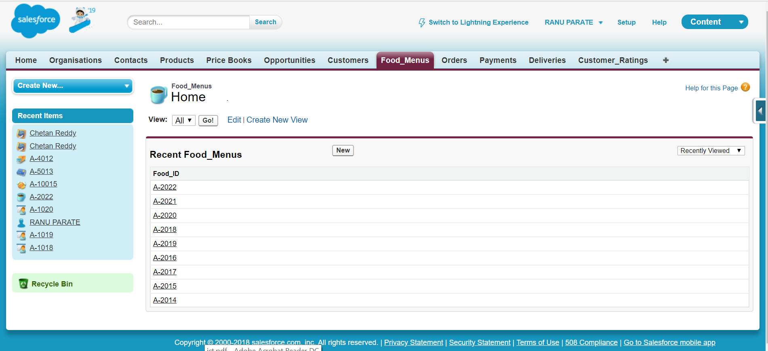

In the object of Food_Menus the information regarding different types of food selected by customer is stored and auto number ID is generated which is assigned to customer who selected food from menus. The food menu is showed in form of picklist as shown below in food menu object field.

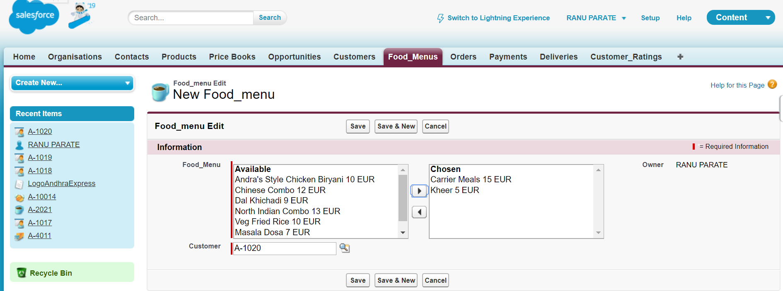

As we can see food item is selected from drop down list with respect to Customer_ID shown below. After clicking save option the Food_Menus field is created as shown. Different food item shown has different price list which connects to payment section.

**Food_Menus fields :**

Food_Menus object shows food selected by customer having attributes of food like Food_ID which is auto Number & Food_Menu, synchronised with Customer_ID.

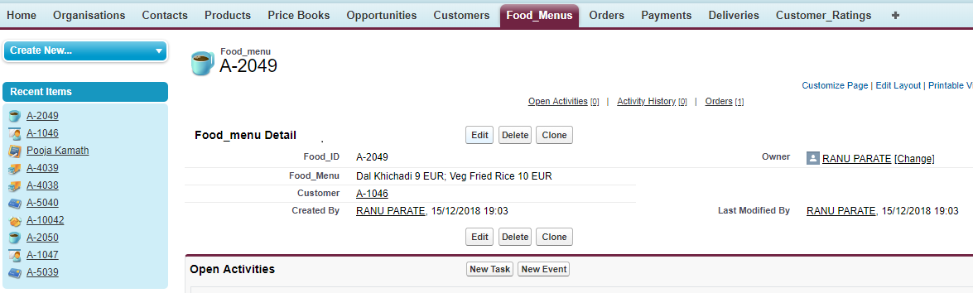

**Orders:**

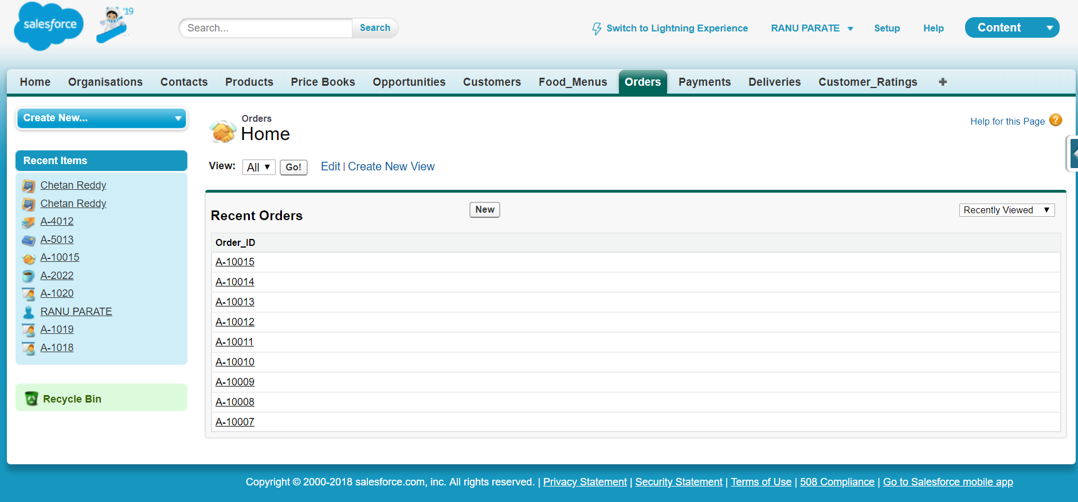

The displayed screenshot shows object Orders under classification of Order_ID which is generated automatically having datatype auto number when details like number of items having data type number, Total_Price by default calculates price of all foods selected by customer.

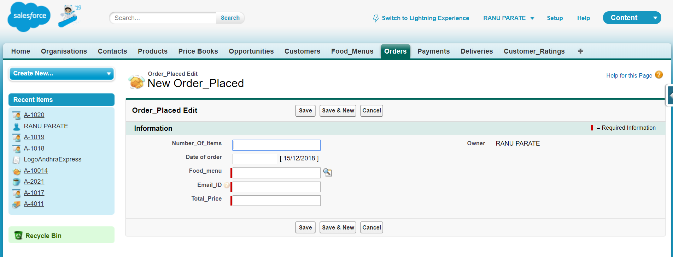

**Orders_Placed Fields:**

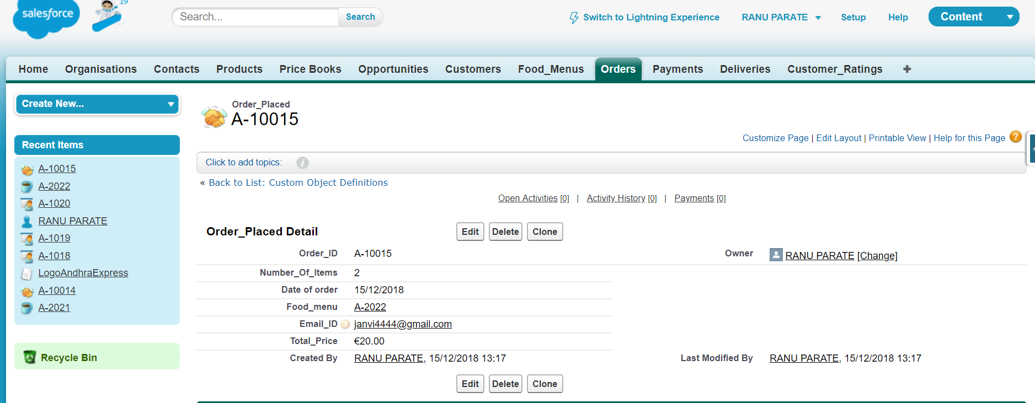

The order objects fields generated is shown below show all attributes of customer with Order_ID attached to it. Various fields like Number_of_Items Email_ID, Date of order by default datatype is Date, of customer is shown after entering all data and saving data in object. Order_Placed fields is created as per diagram above under section of object of Orders. It shows all related data of customer with attributes of Food_menu, Email_ID from different entity this helps user for cross checking and maintaining database.

On Email_ID the concerned person is contacted through email as shown below that required order is placed successfully with same Order_ID generated through system. The mail is successfully triggered by system.

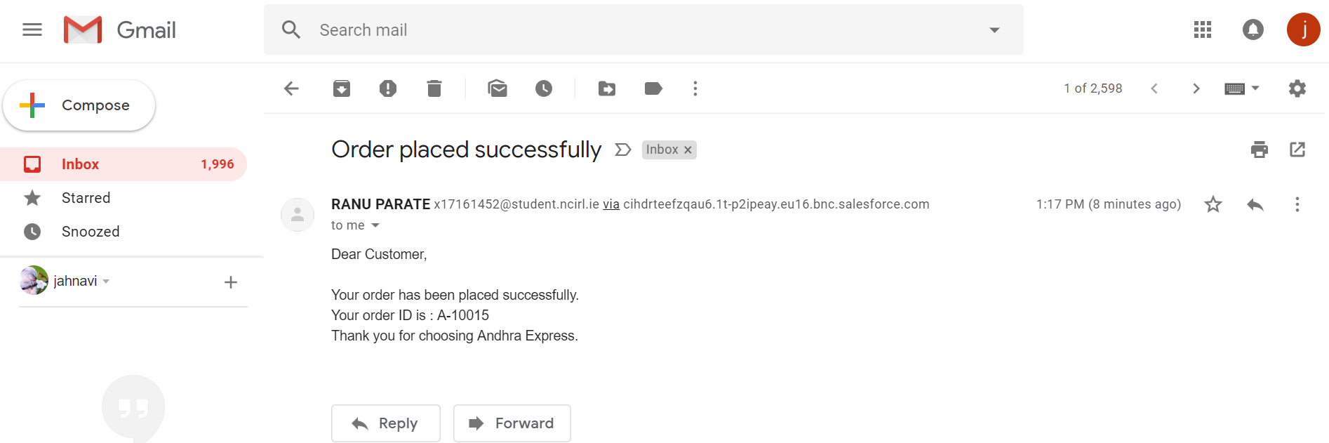

**Payments:**

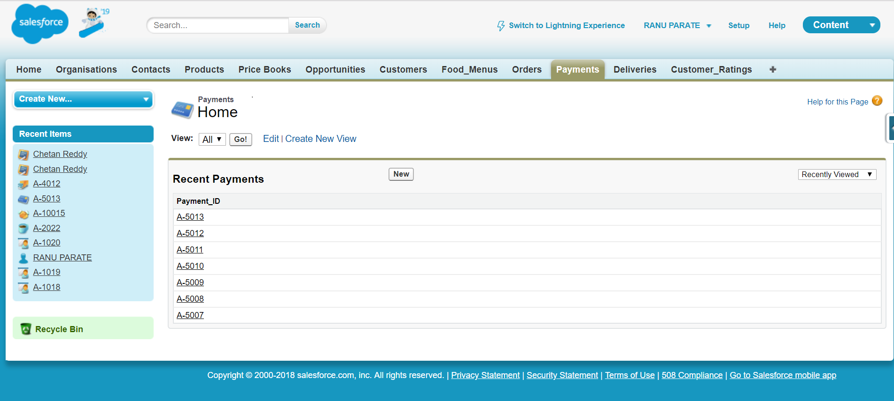

The payment object is created which has payment details of customer ordering the products from food menu. The payment details is classified under attribute Payment_ID which is auto number and generated after choosing mode of payment and doing payment.

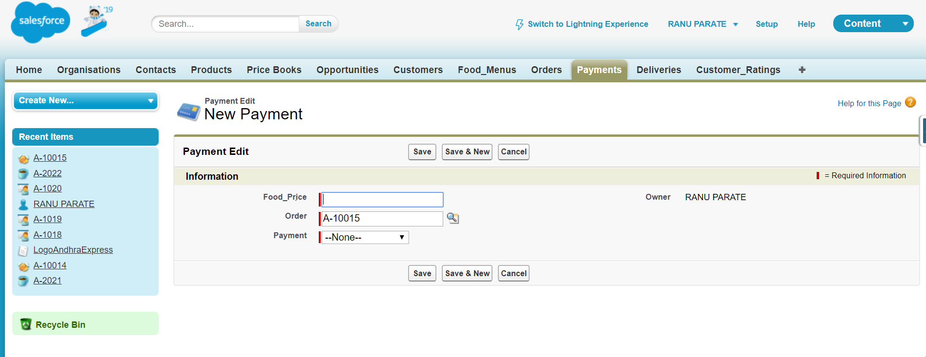

The above screenshot shows payment fields Food_Price datatype as number, Payment fields is picklist type where mode of payment is selected it is directly is connected to Order_ID after saving the entered data the payment field object created as shown below.

**Payment Object Fields:**

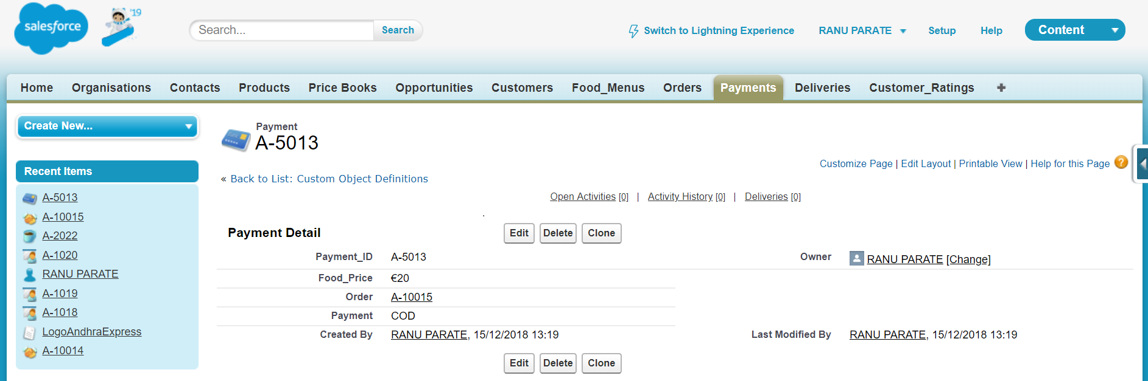

The payment field object created generates Payment_ID which gets attached to Order_ID to maintain linear flow. The Food_Price is sum of all price of food ordered of different quantity. As above example show mode of payment cash on delivery (COD) which is passed on to delivery department.

**Delivery:**

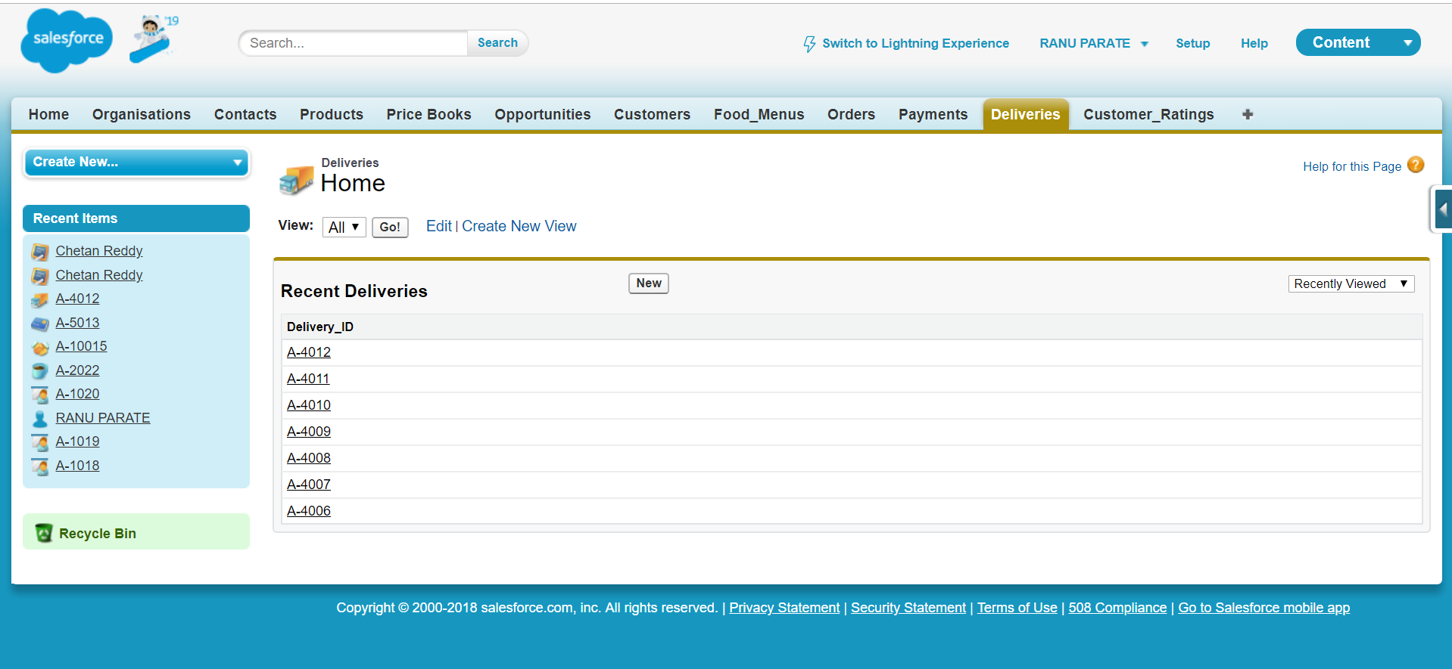

Deliveries object is created where delivery details to receiver is stored under attributes of Delivery_ID. The Delivery_ID is auto generated with data type auto number depends upon mode of payment sometimes it’s created before delivery if payment is done online and if payment is done COD then data feeded. The deliveries field is shown below where appropriate data is put.

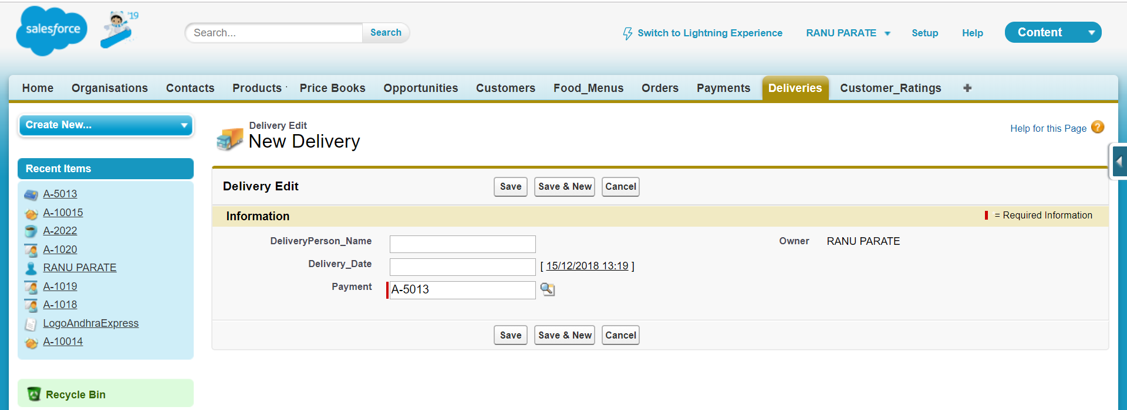

Deliveries objects consist DeliveryPerson_Name fields where person delivering product name is feeded and on date which product is delivered is put in Delivery_Date field as seen Payment_ID is reflected by default, which means Payment object is connected to Deliveries object. After saving with entered data in related field Deliveries object is created with following information in image shown below.

**Delivery Object Field:**

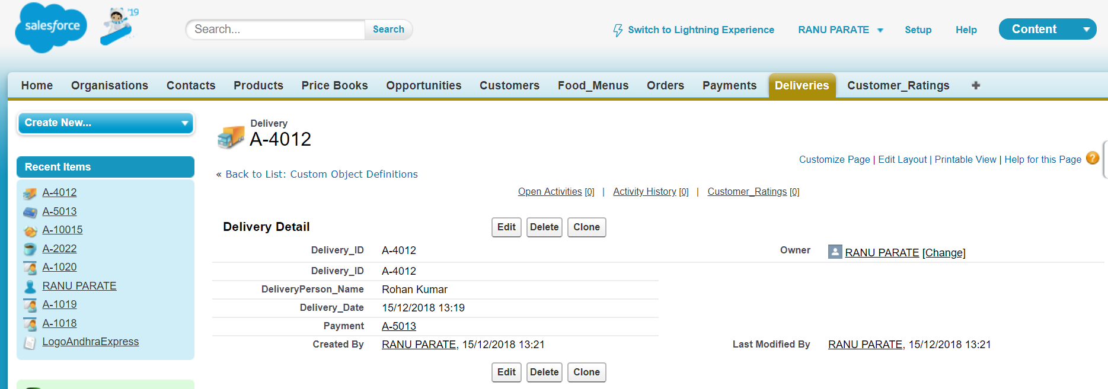

As clearly visible Deliveries field object consist of auto generated Delivery_ID auto number data type assigned as code to delivery details to customer with person name delivering product at particular date.

**Customer_Ratings:**

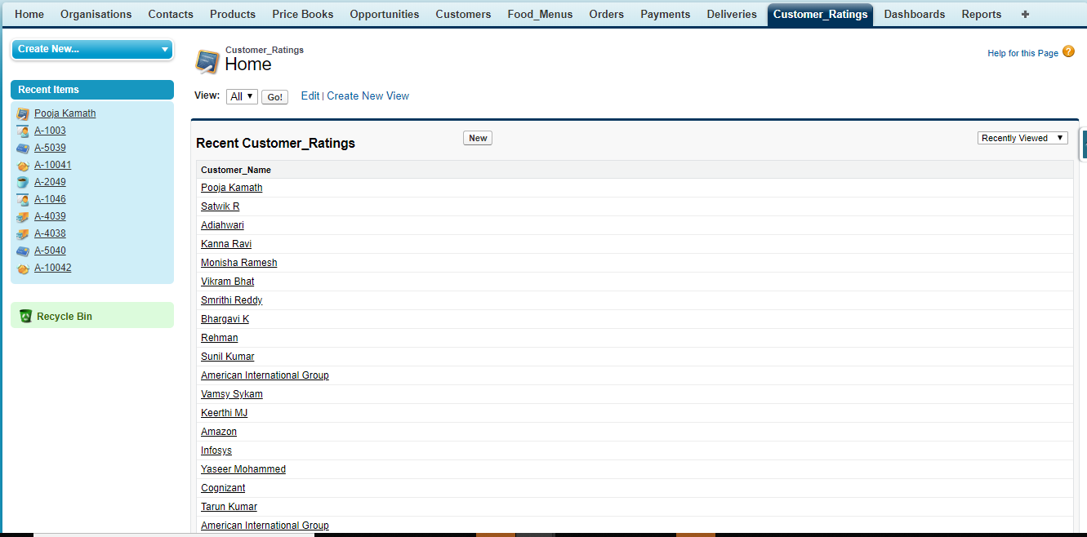

Object Customer_Ratings is reviewing object where customer feedback is stored regarding product delivered under section Customer_Ratings which connects with Customer details for business use. These object of following fields shown in diagram below

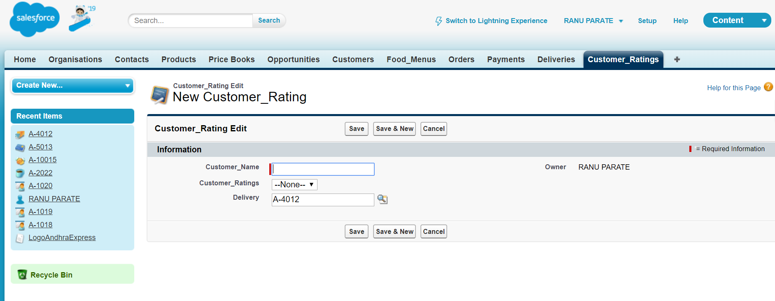

The Customer_Rating consist of fields Customer_Name as text data type, Customer rating as numeric data type from 1 to 5 and Delivery_ID is automatically assigned to customer ratings. After completion of data entry in field we get Rating_ID.

**Customer_Rating Object field:**

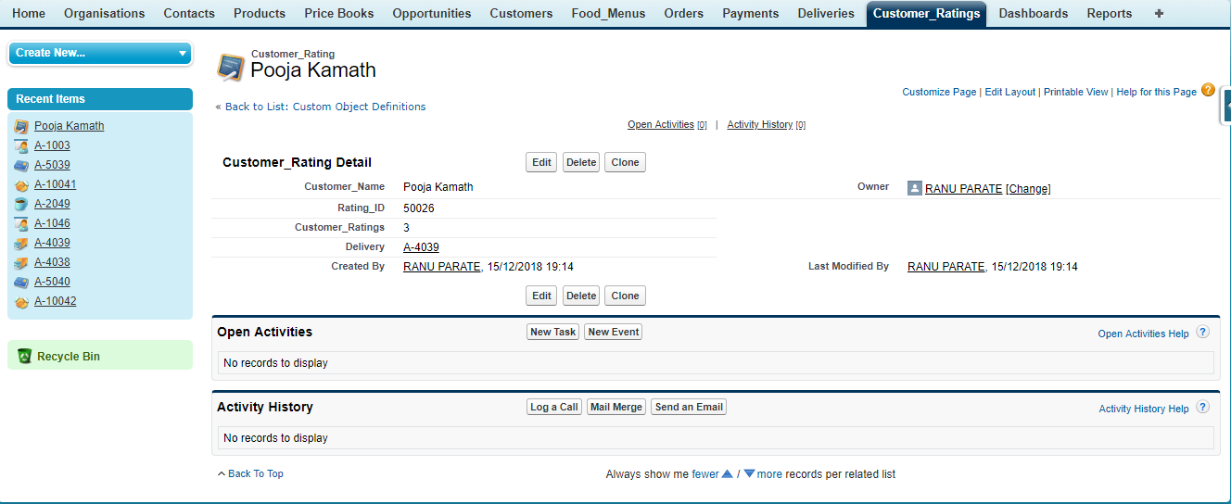

The figure clearly shows object created consist of Customer_Name, system generated auto number Rating_ID connected to Delivery_ID and ratings given by customer in form of numbers.

**Validation Rule:** Its simple pre-set of defined function which is used to check the accuracy of details by entered by user by exception error handling method which benefits user to validate the page with proper guidelines.

**Validation Rule for Customer:**  To detect error in initial phase and make accurate interactive platform we have created some function as form of validation rule for different objects. Validation rule for Customer object is shown below in diagram

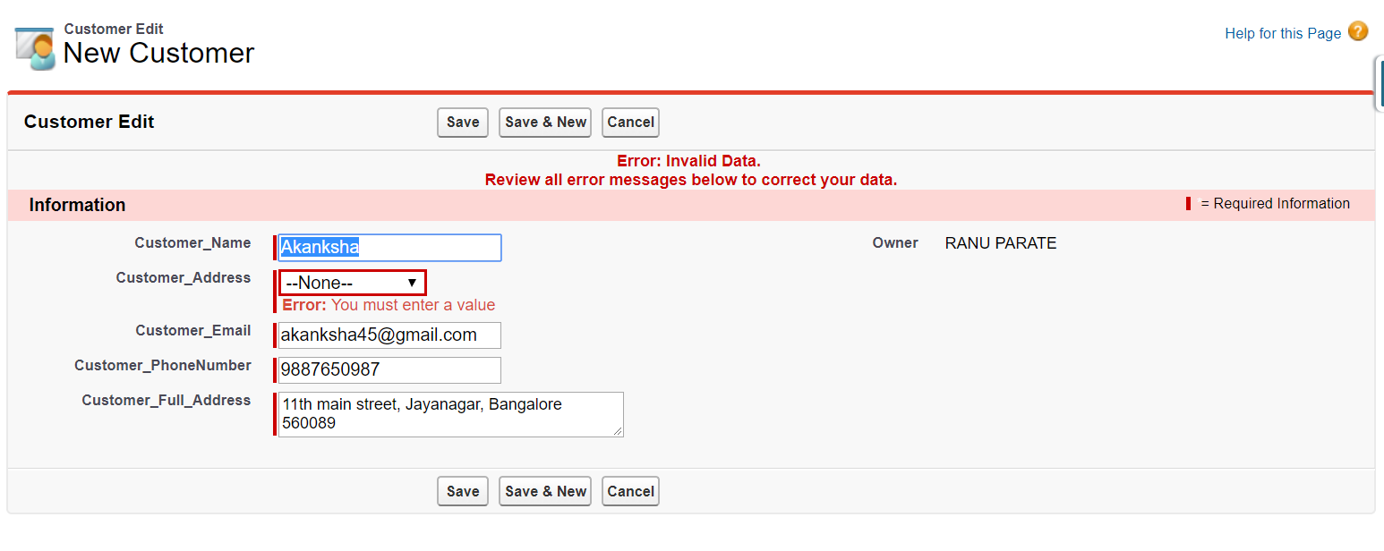

In above figure user has purposely not filled Customer_Address field which has thrown error, in form of pop up message which refrains user to move to next page until he fills all data. This is process of checking validation of Customer object.

**Validation Rule for Food_Menus:**  For food menu object validation rule is clearly set with function that states if user doesnot select food items selected by customer error is thrown at screen as seen from diagram below

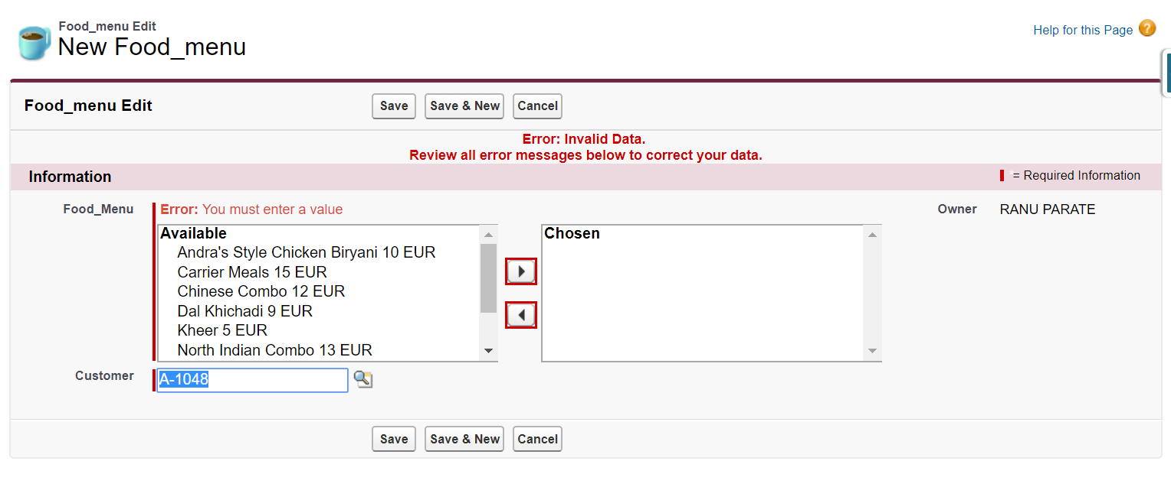As seen from above illustrated figure the error message pop up at top which clearly states user to select one of values from pick list to proceed to next step.

**Validation Rule for Order_Placed:**  Validation rule for Order_Placed have number of fields which needs to be filled by user operating the platform like Number_of_Items, Date of order, Email_ID, the process is same as like other objects mentioned above.

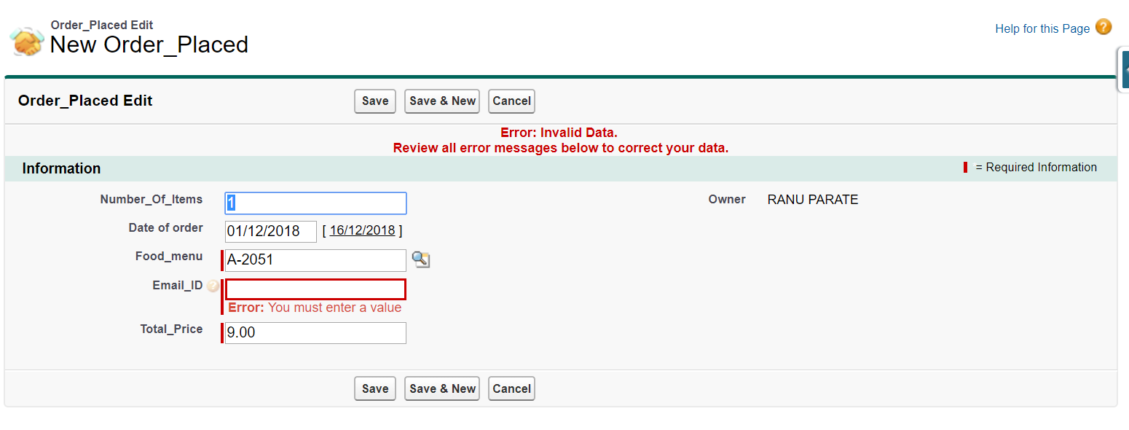From image above user has got error message of invalid data and asked to correct the data, because Email_ID field is left blank.

**Validation Rule for Payment:** Only two fields required in Payment object required detail filling one Food_Price and next Payment fields to avoid error message and ensure user the appropriate functioning of the payment page.

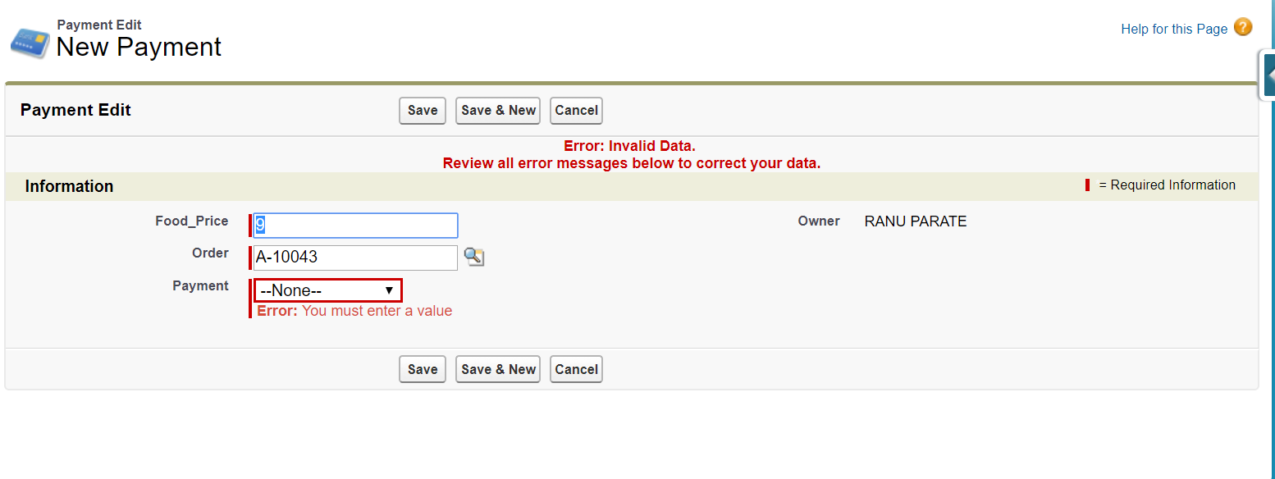

The figure above shows the error message which occurred due to payment option left blank by user. After filling the desired option the user can move to final process.

**Schema in Schema Builder:**

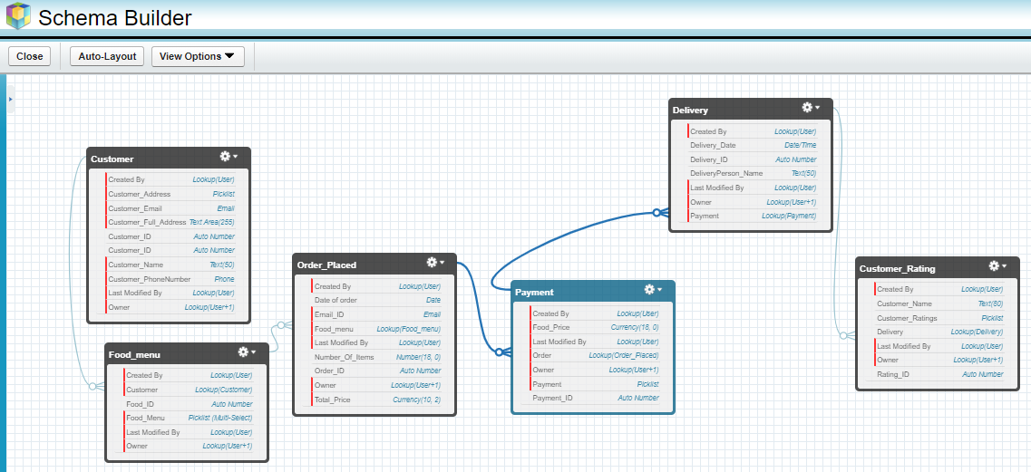

The above image demonstrates the objects that are created as per the requirement of the organization functionality are linked to each other. These objects forms the base of the organization and it is necessary to be managed. All the build up and management of relationships for the various objects that are created for the organization is done with the help of Schema Builder using the keys which are present inside each object. All these tasks are handled by an expert of Salesforce in an organization.

In our CRM implementation there was a requirement for 6 objects and are organized in a manner so that it demonstrates the business flow of our organization.

**Generating Email Alerts:**

In this project implementation we have setup a process to generate emails alerts at two crucial points of the business.

1) When a new customer registers with our company

2) When the customer makes a purchase for us.

This kind of a e-mail notification signifies success at any of these points i.e successful registration or successful order placing as an Invoice.

The following are the two email alerts that are taken into use as shown in the image below.

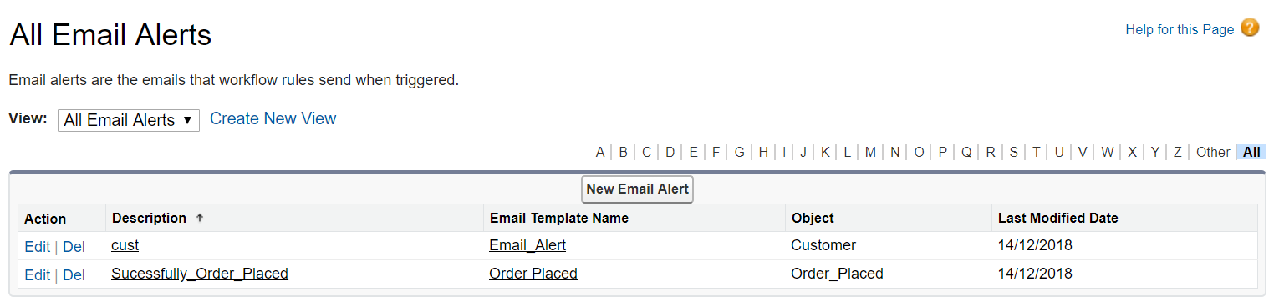

For creating email alterts, firstly we customize the email template for both the emails that are going to be used for the business. After that a workflow rule is created in which we set workflow actions consisting of email alerts. The main step is to set it to active mode so that it could be activated for use.

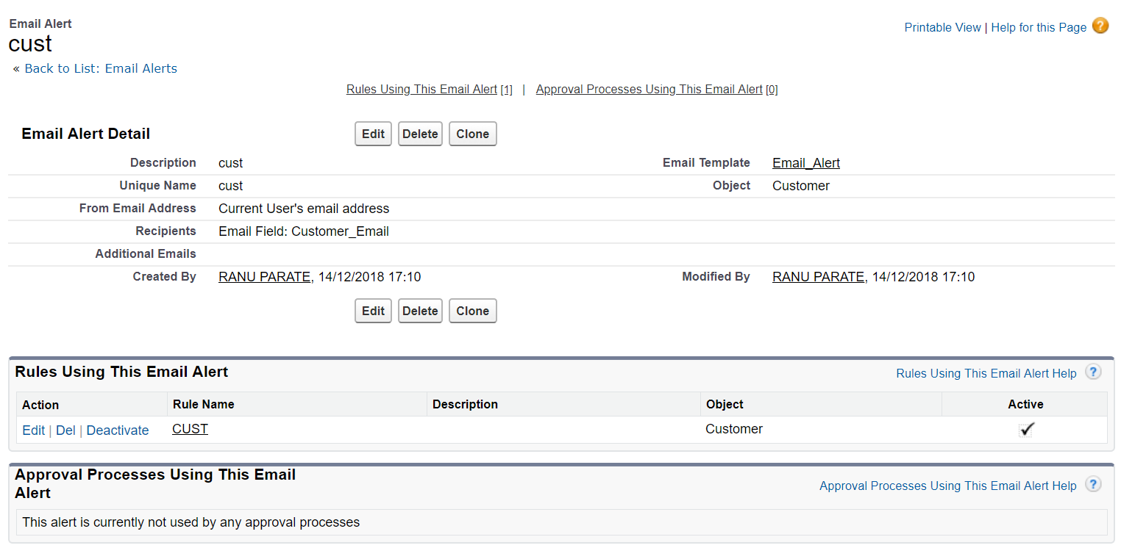

This above screenshot is a more detail view of the email alert that is generated when a new customer registers with our organization. As it can be seen the alert is set to active mode which means that it is in use. This email alert will be sent to the concerned customer. For testing purpose we have registered with one of our personal email ID so as to check the working status of the email alerts.

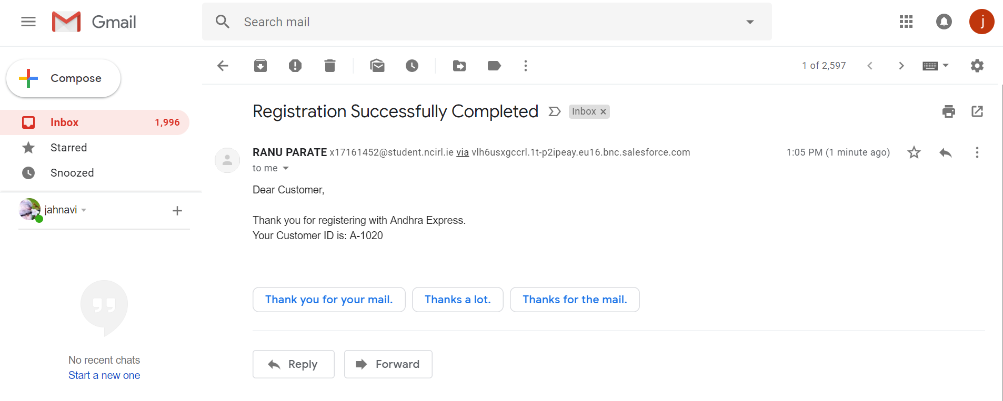

As it can be understood from the above screen shot that the customer has received an email suggesting his/her successful registration with the organization and also has been allocated with a Customer ID which can be used for ordering purpose.

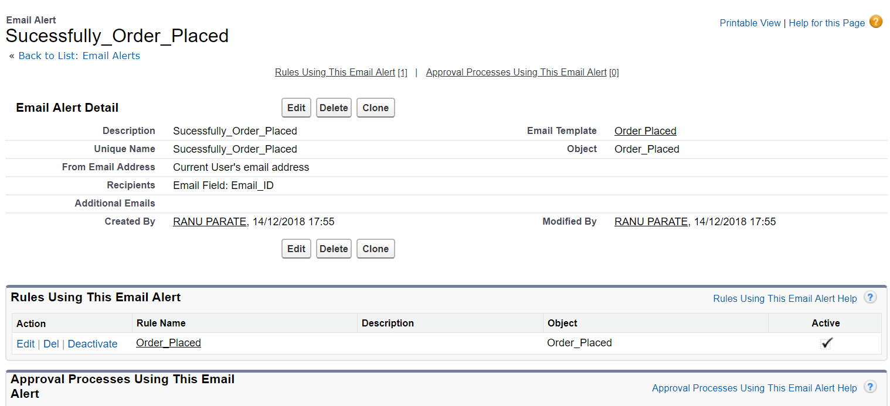

The above image gives the detailed insight for the mail generated when an order is placed by a respective customer. For a confirmation purpose an email is sent to that customer. Even this alert is set to active state it is in use. This mail is forwarded to the concerned customer.

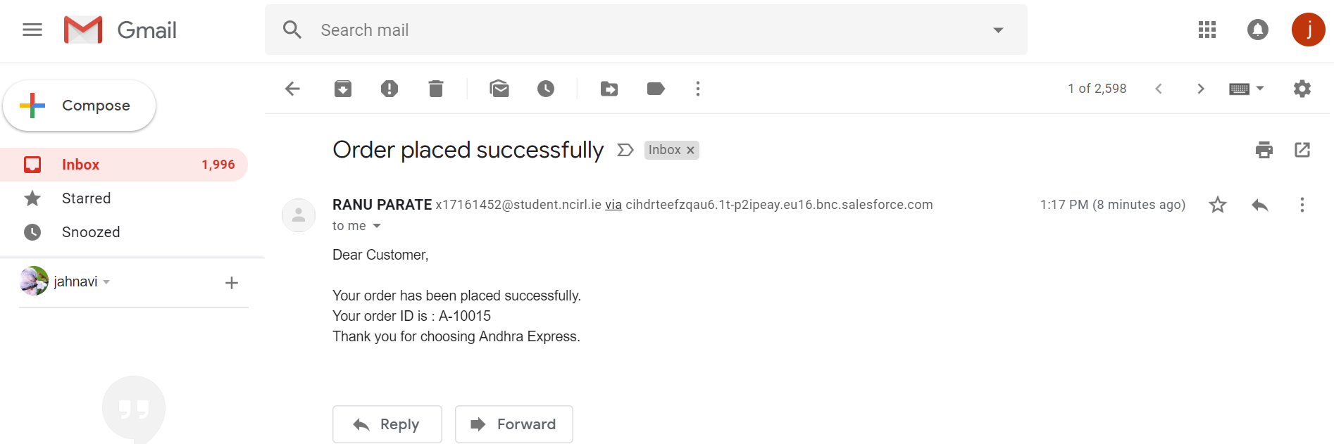

As from a customer point of view he/she will receive such type of email when they place a food order from our organization. It also consist of the order ID that is generated for the particular invoice.

User Interface:

The organization of the organization is designed using custom features that are available in Visualforce. Apex is the programming language that is used to code the interface.

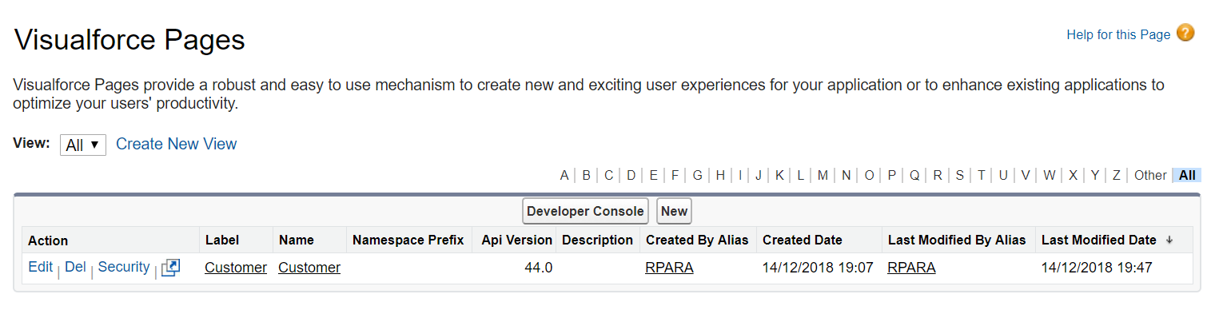

As we can see from the above illustrated image shows the customer page that is designed.

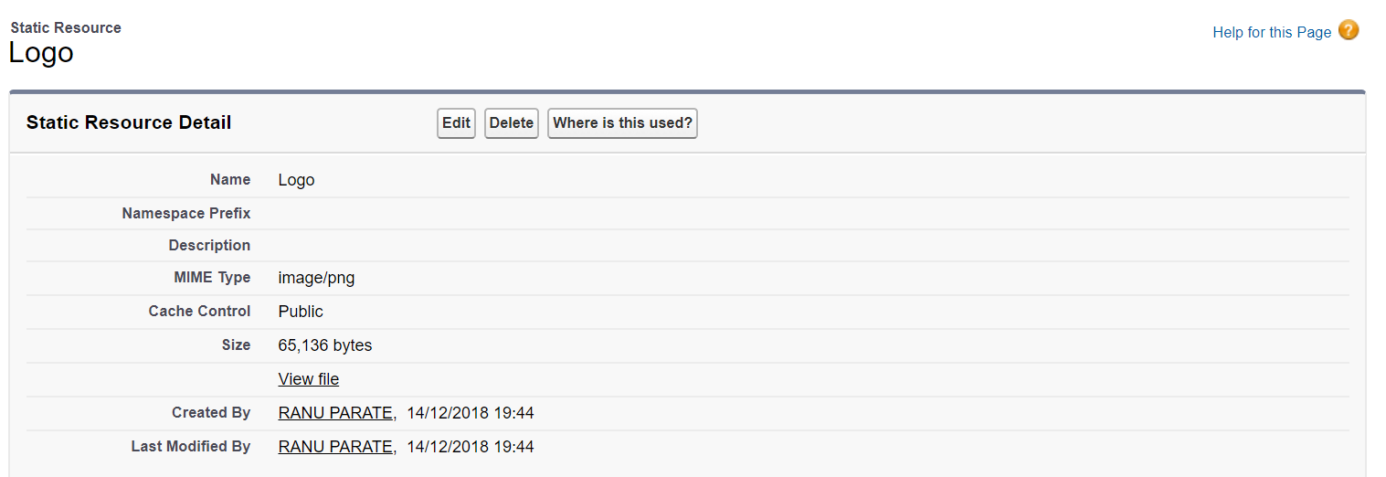

In the static resource page there is detail description about the inclusion of an image which signifies the logo of the company in form of a resource.

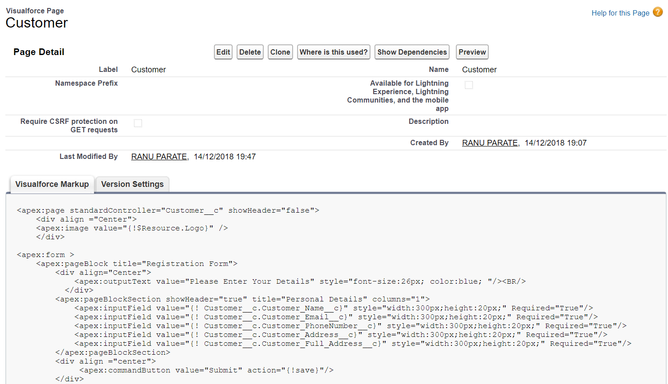

This snippet of Visual force page is where the coding for the webpage is written and executed. We have selected the theme and colour as per the logo of the company. We have created input fields as per the requirement and all the fields are kept mandatory so as to complete the registration.

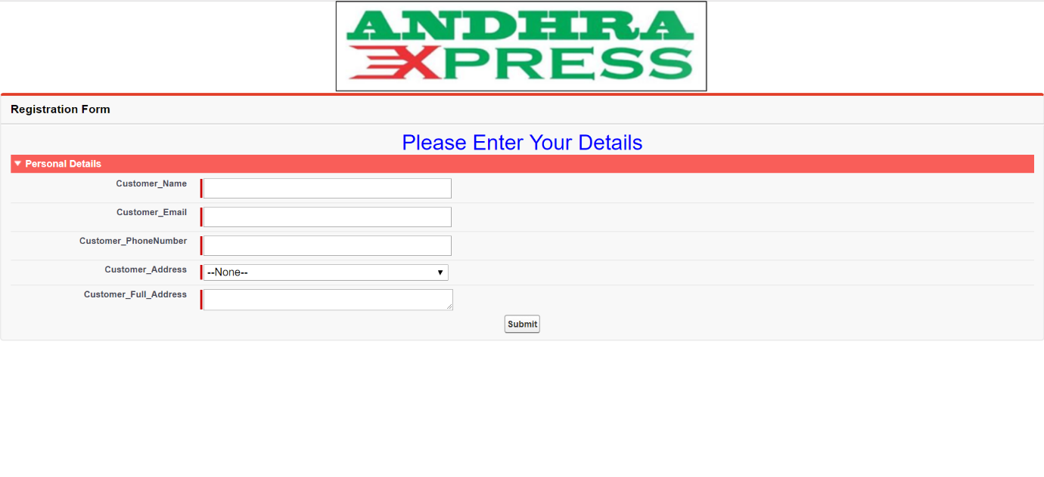

The above page shows how the default webpage looks when it is loaded and the below image shows how the page looks like when data is entered. If a person tries to enter invalid data into the input and tries to complete the registration by clicking on submit the page will pop up with a validation error requiring user to input the data as per the required pre-set validation standards.

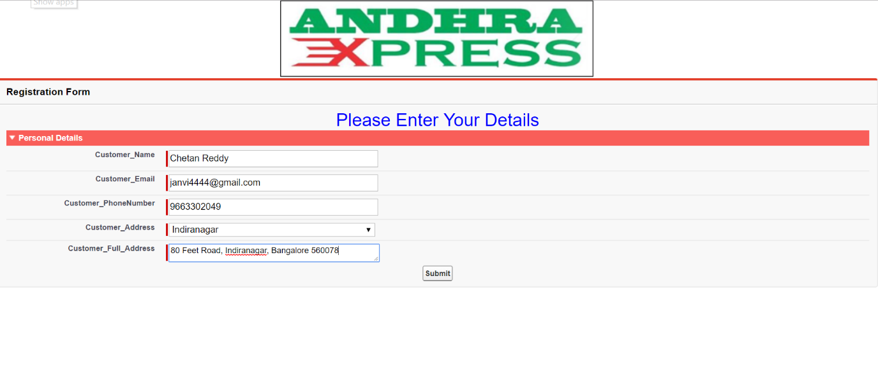

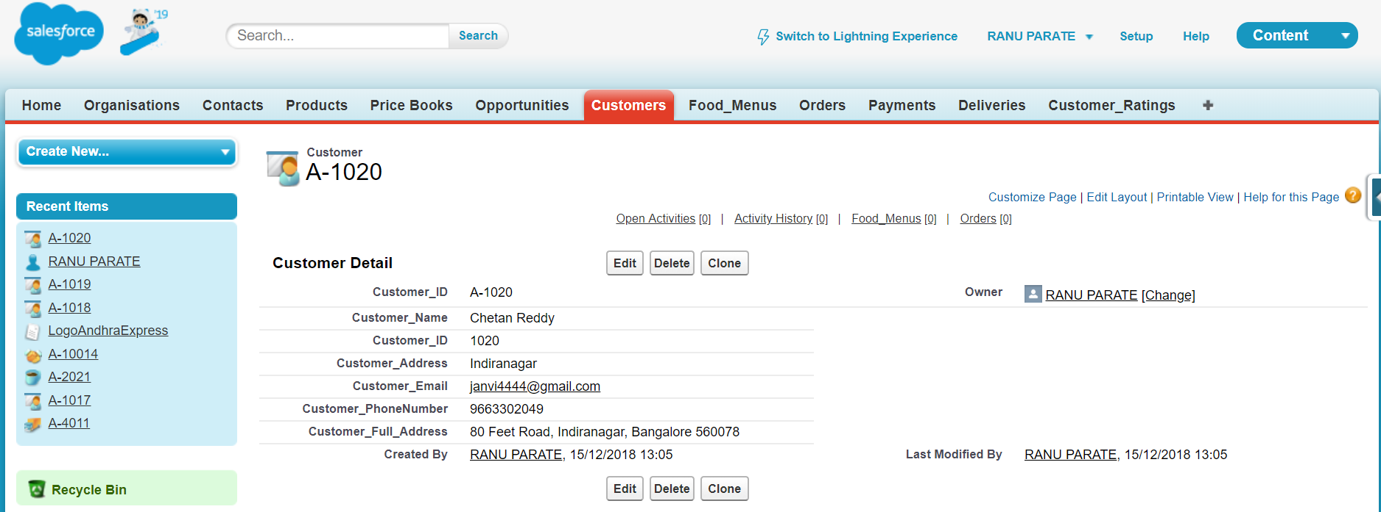

The above picture demonstrates how the newly entered data i.e. the new customer details which are entered by the customer are stored in the background whereas for the means of confirmation the user receives an email which also provided him/her with their unique Customer ID as well.

**Future scope** This project has quite various nodes in it which can be expanded in a systematic manner while maintain the proper functioning of the organization. One of the major factor which affect the sales of a particular organization is the location range. This particular implementation is limited to 5 km range for the delivery of its meals as the organization is a newly developed one and it will take certain time for it to grow and spread so that it could attract more and more customers by establishing new branches.

Secondly aspect that could be explored is the service time. In this case the delivery time is an important aspect that should be managed efficiently by the organization and this should work in a structured manner. Also to improve the service i.e to cut down as much time as possible so that the product reaches to its designated customer within very less amount of time the outsourcing approach can be opted by the organization in partnership with e-tailers such as Zomato and Swiggy could assist our organization in delivering the food.

Apart from all the above mentioned things, another important space for expansion is by opting the already in-use Salesforce platform to manage all the staff information and by managing their salaries as well as monthly performance evaluation can be done using this platform. As the number of food items are limited as the company is a fresh start-up it will require certain time to catch up speed after which the more meals could be added into the menu.

**Team member workload contribution**

In these project all 4 team members have contributed equally through co-ordination and helping each other in development, adding platforms features details in report. Workload was initially divided equally as 2 people were engage in building platform and rest two were indulged simultaneously understanding platform and formatting report according to it. Starting from initial stage of understanding features of salesforce to final stage of making fully serviced CRM platform lot of changes were made by discussion around what features can be added or modified by report preparation team. And successfully we were able to match all set guidelines for project before deadline. We would like to also thank our project co-ordinator by providing us valuable apex code details on moodle so we can understand the basic of apex programming for building web pages. Before submitting the project every project member concern was taking and after that we have arrived to conclusion this is our final project with no changes. Please find details of team member and there contribution in project.

|  |  |  |
| --- | --- | --- |
| Student Name | Student Number | Workload Distribution |
| Ranu Kishor Parate | x17161452 | 25% |
| Jahnavi Kacharakanahalli Shesha Reddy | x17170010 | 25% |
| Samir Salim Khan | x17161461 | 25% |
| Anurag Abhay Singh | x18104053 | 25% |